The Eyes Have It
Kimberley B.C. Goh, M.D.
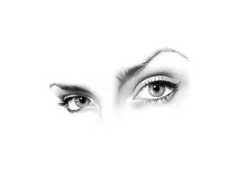
Your eyes draw attention.

When someone meets you they pay attention to your eyes. Your eyes convey emotion and direct attention. Many of us feel that as we age our eyes are actually not a true reflection of how we are feeling. Especially when your eyelids start looking heavy and bags start accumulate under them; you may look tired even when you are not.

If your upper lids are hooded removing some of the excess skin and fat can make them look more open, and less heavy. Your eyes will appear brighter and more alert. The upper lid blepharoplasty incision is usually within the crease, and both skin and fat is usually removed. The under eye bags are addressed by with a lower lid blepharoplasty, this procedure is performed by making an incision either inside the lower lid or just underneath the lashes and the fat pads are thinned. Often the muscle is repositioned and this helps tighten the lower lid area.

Sometimes the hooding of your upper lids is caused by your brows descending, not excess skin or fat in the upper lid. This can be partially corrected non-surgically by a very careful placement of Botox, or it can be resolved with a brow lift. A brow lift can also help with the frown lines between your brows and crow’s feet.

If your skin is very wrinkled or crepey then the skin itself need to be treated. This can be done with topical treatments, such as Vitamin C in a special cosmeceutical formula and Retin A and other various treatments. Additional skin rejuvenation techniques include the various chemical peels or laser resurfacing (either full resurfacing or fractional). The topical skin treatments take about two months to see the improvement in your skin.

The brow lift, eye lid lift and some of the skin resurfacing procedures can take a week or two for the swelling to go down and bruising to fade. Plan your procedure for enough time to recover. When you are choosing your surgeon, make sure that the surgeon is board certified by a specialty recognized by the American Board of Medical Specialists, that they have privileges at a local hospital and that the facility where the surgery is performed is also accredited.

